Biceps brachi

Origin:
- Long head – supraglenoid tubercle
- Short head – tip of coracoid process
[TIP] Tendon runs within the joint capsule.
[WARNING]Tendon of popliteus is the only other tendon that is intracapsular

Insertion:
- Posterior part of radial tuberosity
- Through bicipital aponeurosis it is inserted into the deep fascia of forearm
[WARNING]Insertion to posterior aspect gives leverage for supination
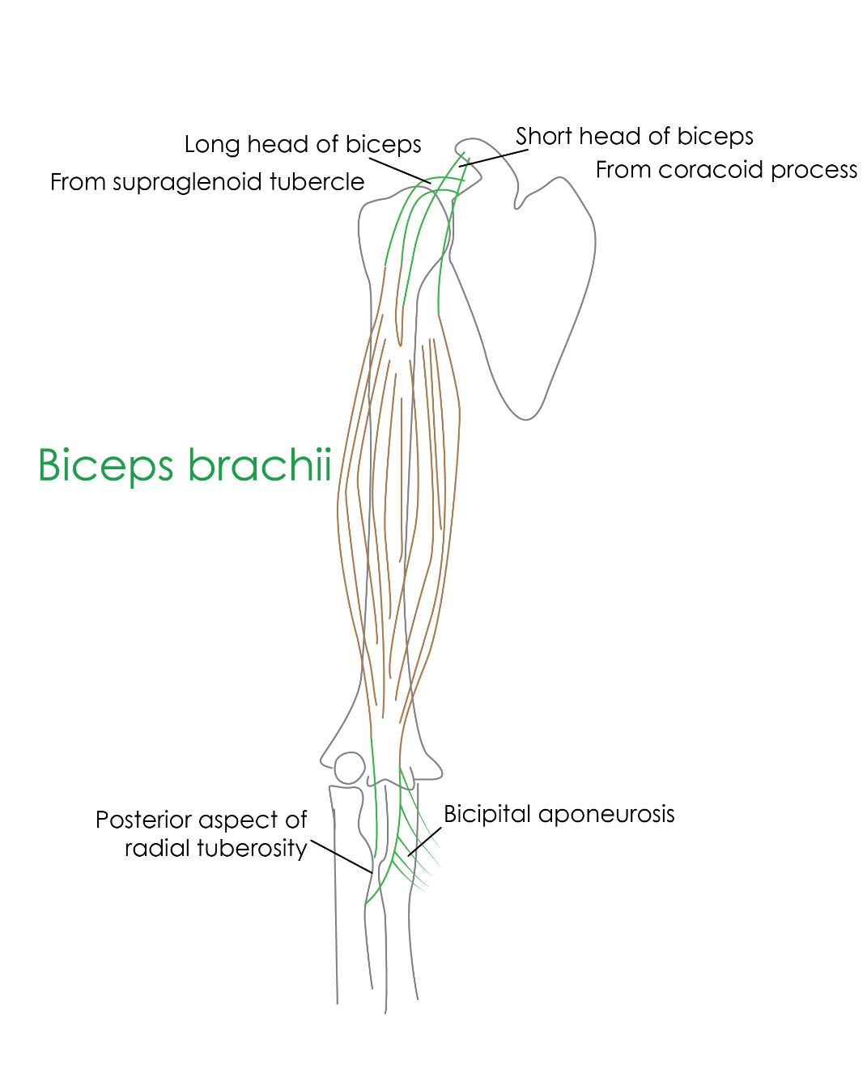
Nerve supply:
Musculocutaneous nerve (C5,6)

Actions:
- Supination of forearm – biceps brings powerful supination of forearm
- Elbow flexion
[CLINICAL]Clinical testing – asking the patient to flex against resistance
[TIP]Biceps jerk – sudden strong stretch of tendon of biceps brachi – brings biceps jerk. Centre is at C5.
[NOTE]Biceps – powerful supinator; that is the reason behind, threading screws in such a way that supination brings tightening .

Coracobrachialis
- Origin: from tip of coracoid process of scapula
- Insertion: middle of medial border of humerus
- Nerve supply: musculocutaneous nerve
- Action: adduction of arm and weak flexor of arm
- Functional representation: represents the medial compartment of limb (adductor compartment in lower limb)
Ligament of struthers: the lower extension of coracobrachialis to medial epicondyle or medial supracondylar spur; median nerve and brachial artery passes beneath the arch formed this fibrous band

